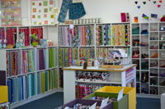
Front Page
Welcome to Addicted To Fabric. We are a leading Australian patchwork and sewing store, specialising in traditional, eclectic and contemporary fabrics, combined with notions from around the world. We are owned and operated by women who sew and look forward to welcoming you... more

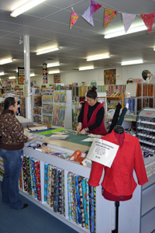
About us page
Addicted To Fabric is an independent store, owned and operated by women who sew. All our staff are experienced with patchwork and fashion fabrics and sewing techniques – we are passionate about our products and services.
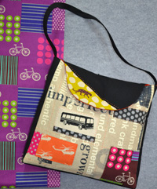
We offer a comprehensive range of fabrics and are well known for our collection of eclectic and contemporary designs as well as the traditional and standard ranges. We source our fabrics from the latest collections in New York, Tokyo, London and Europe. We are also strong supporters of artisan Australian designers and feature hand printed and designer fabrics.
To coordinate with our fabrics, we maintain a comprehensive range of the best sewing and patchwork notions, patterns, books and we use and sell the PFAFF range of sewing machines. You will find some great ideas for sewing projects that cross our entire range – bag patterns teamed with the latest stylish patchwork fabrics from Japan
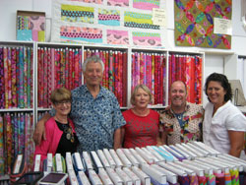
We run a series of workshops ranging from Beginners’ Patchwork or Dressmaking through to more advanced classes drawing on the skills of the best local, interstate and international tutors including Kaffe Fassett, Sue Spargo and Becky Goldsmith.
We also stock a big range of dress patterns including Vogue, Burda, New Look, Kwik Sew, Butterick and Simplicity.
Addicted To Fabric hosts a number of Friendship Groups that meet in the store for some sewing therapy and a chat. We look forward to welcoming you to our store and hope you enjoy your experience with us.
Whatever your sewing project, we can help with all your needs and that little something extra to make your project unique and distinctive.
