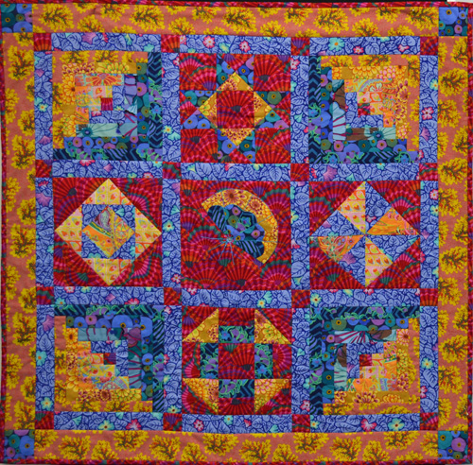
Beginners Patchwork with Wendy Saclier

Ever popular, Wendy Saclier continues to tutor our beginners' course. Over eight weeks Wendy will teach the basics for strip piecing, applique, hand piecing and foundation techniques. You will be able to complete your quilt during the program. This is the perfect way to get you stated on the journey to your first quilt.

Booking Details:
Level of skill required: Beginners
Starting Date(s): 26 July and 18 October 2011
Ending Date(s): Yet to work these out Noel 2011
Duration: 8 Tuesdays
Hours of attendance: 10am-12.30pm or 6pm to 8.30pm for eight Tuesdays
Amount of attendees allowed: 10
Cost: $165



